SDS Deployment Planning

Contents

Objective 1

Background 1

SDS Identity Matching 1

SDS Limits 1

Office 365 Hybrid Identity - General Recommendations 2

Planning SDS Deployments 2

Planning Checklist – Gather your information 2

Multiple Domains 2

Recommendations 2

Large Districts 2

Recommendations 2

Intune for Education 2

Recommendations 2

Summary 2

# Objective

The objective of this article is to provide general guidance for planning a School Data Sync (SDS) deployment.

# Background

To effectively plan an SDS deployment, there are some pertinent details regarding Identity matching and SDS limit which you need to understand, that will subsequently impact your overall SDS enablement plan.

## SDS Identity Matching

When configuring SDS, we must match each student and teacher identity from the source directory (SIS or CSV files) to the same user’s identity in the target directory (Azure Active Directory). In order to do this, we must choose between the 3 available attributes from the source directory. This selection within the SDS sync profile will use the selected attribute as a simple string value. This string value must match the exact value contained in one of the 3 available target attributes within Azure. You also have the option to append a domain suffix to the source value to complete the match, as shown in the example below:

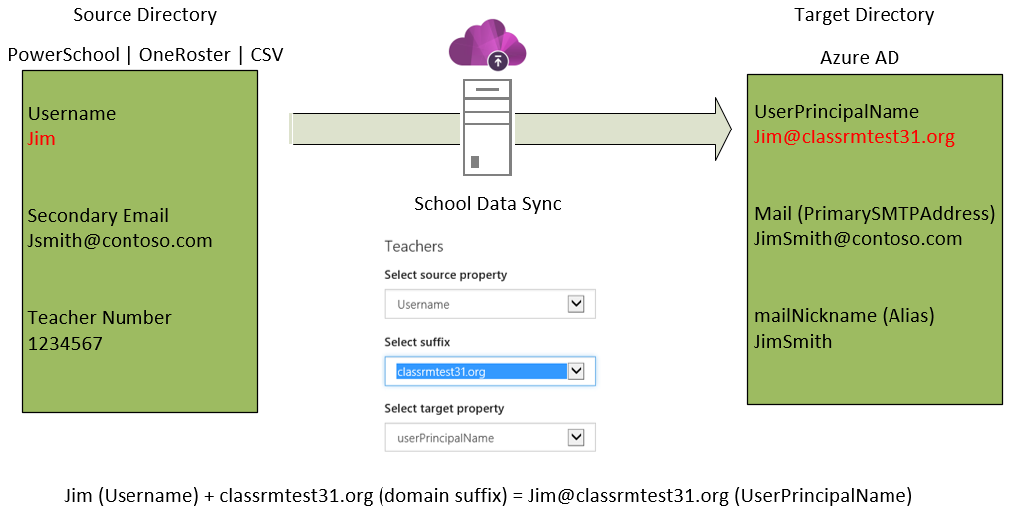

Since you can only configure 1 set of identity matching options for teachers within a single sync profile, and 1 set of identity matching options for students within the same profile, you may need to create additional sync profiles to match 100% of your teachers or students. Microsoft recommends creating as few sync profiles as possible. This recommendation is for performance reasons, although there is no current limit on the number of sync profiles you can create. If you don’t require updates/changes to be processed in a timely manner, creating a large number of sync profiles may not be an issue. If you need SDS to sync changes within a given day, we recommend creating no more than 3 profiles per O365 tenant. Updating your identity matching attribute values in either the source directory or target directory may be an possible if you need to reduce the number of required sync profiles due to the identity matching option requirement (domains selection or source/target attribute selection).

## SDS Limits

* Number of Sync Profiles - text
* Number of domains per profile - text
* Number of users/rosters per profile – text

# Office 365 Hybrid Identity - General Recommendations

* Domain consolidation – where, when, why

## Bringing Domains to O365

text

## Consolidating Domains in your on-Premise AD

text

## Additional Resources

text

# Planning SDS Deployments

* Paragraph - text

## Planning Checklist – Gather your information

* Question 1
* Question 2
* Question 3
* Etc.

## Multiple Domains

* Text overview – how multiple domains impacts your SDS deployment

### Recommendations

* Text overview – based on potential impact, this is what we recommend and why

## Large Districts

* Text overview – how large volume of users/rosters impacts your SDS deployment

### Recommendations

* Text overview – based on potential impact, this is what we recommend and why

## Intune for Education

* Text overview – how Intune for Education impacts your SDS deployment

### Recommendations

* Text overview – based on potential impact, this is what we recommend and why

# Summary

Text